Gilead Sciences
Dubai Healthcare city
Building 24 5th floor
Date: 11Jan 2022
Sponsorship Letter
Dear Dr. Howaida Abdelwahab,
On behalf of Best of San Antonio Conference Committee, I would like to thank Gilead for your interest to support the Best of San Antonio Conference which will be held on 28th-29th January 2022 (hybrid) at VOCO Hotel, Riyadh.
This conference is designed to provide and allows healthcare professionals, the opportunity to experience and discuss the research and advances with colleagues and key opinion leaders. Hence, the attendees of the 16th MESABCS program will receive the most current information on breast cancer research presented in the original format delivered at the meeting in San Antonio in Jan 2022. Moreover, they will learn of the current advances in breast cancer research that are changing clinical practice for the benefit of the patients
Following we would like to offer you the below privileges as GOLD Sponsor, with total amount is (250,000 SAR) including VATs:
Details of the agreed benefits
-Company name and logo printed on all publications Signage at conference identifying you as golden sponsor
-Name and logo on all conference communications and on website
-Premium placement of company - provided banner or roll up in plenary room and VIP Room
-3 full page in the conference booklet (A4 Size) (digital edition)
-3*6 (15 SQM) booth size
-Satellite symposium
A- 30m within the agenda (Hybrid)
-1 Short video (3m) will stream in the break tow times (Hybrid).
-Attendee's list (online and physical).
-5 free physical attendance registration.
- Gilead Video to be send at the end of the conference along with Attendance certificate
- Gilead logo on conference booklet
- We will announce the satellite symposium (Sponsor Session) on the website
All packages must be payable to the Congress Organizer in charge of handling sponsorship contracts:
The Payment will be directed to the organizing company Organizing Team of The Commercial Services Est. (Event Troop)
as mentioned below:
Beneficiary details:
Account Name : Organizing Team of The Commercial Services Est. (Event Troop)
IBAN : 6253903000103 IBAN | SA3510000006253903000103
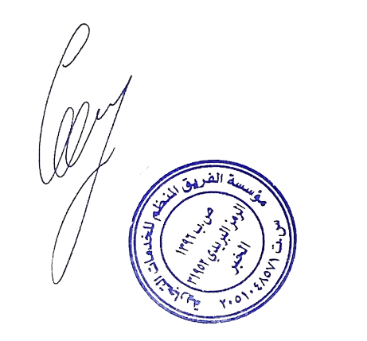
Bank : National Saudi Bank (SNB)
General Manager
Ahmed Elewa
Ahmed Elewa

